11. ReactJS-HOL

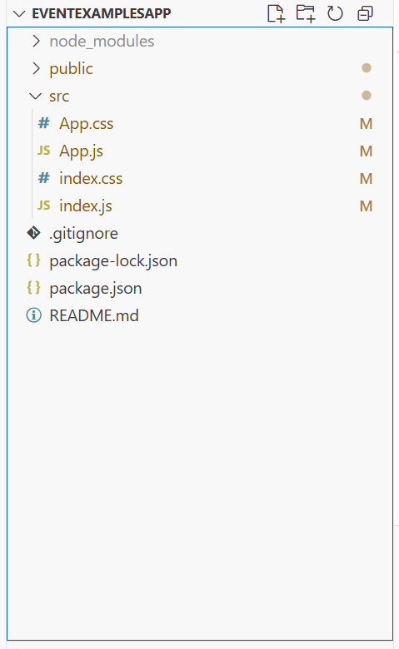

Index.js
import React from "react";
import ReactDOM from "react-dom/client";
import "./index.css";
import App from "./App";

const root = ReactDOM.createRoot(document.getElementById("root"));
root.render(<App />);

App.js

import React, { useState } from "react";
import "./App.css";

function App() {
const [count, setCount] = useState(5);
const [amount, setAmount] = useState("");
const [currency, setCurrency] = useState("");

// Increment and say Hello
const handleIncrement = () => {
setCount(count + 1);
alert("Hello! Member1");
};

// Decrement
const handleDecrement = () => {
setCount(count - 1);
};

// Say welcome
const sayMessage = (msg) => {
alert(msg);
};

// Synthetic event
const handleSyntheticClick = (e) => {
e.preventDefault();
alert("I was clicked");
};

// Currency conversion
const handleSubmit = (e) => {
e.preventDefault();
let convertedValue = 0;

if (currency.toLowerCase() === "euro") {
convertedValue = amount * 80; // Example: 1 Euro = ₹80
alert(`Converting to Euro Amount is ${convertedValue}`);
} else if (currency.toLowerCase() === "inr") {
convertedValue = amount / 80;
alert(`Converting to Rupees Amount is ${convertedValue}`);
} else {
alert("Please enter a valid currency: Euro or INR");
}
};

return (
<div className="container">
<h3 className="header">React App</h3>
<p className="counter">{count}</p>

<div className="buttons">
<button onClick={handleIncrement}>Increment</button>
<button onClick={handleDecrement}>Decrement</button>
<button onClick={() => sayMessage("welcome")}>Say welcome</button>
<button onClick={handleSyntheticClick}>Click on me</button>
</div>

<h2 className="title">Currency Convertor!!!</h2>

<form onSubmit={handleSubmit} className="form">
<div className="form-group">
<label>Amount:</label>
<input
type="number"
value={amount}
onChange={(e) => setAmount(e.target.value)}
required
/>
</div>
<div className="form-group">
<label>Currency:</label>
<input
type="text"
placeholder="Euro / INR"
value={currency}
onChange={(e) => setCurrency(e.target.value)}
required
/>
</div>
<button type="submit" className="submit-btn">Submit</button>
</form>
</div>
);
}

export default App;

App.css
.container {
padding: 20px;
font-family: Arial, sans-serif;
}

.header {
margin: 0;
}

.counter {
font-size: 22px;
margin: 10px 0;
}

.buttons {
margin-bottom: 20px;
}

button {
display: block;
margin: 5px 0;
padding: 8px 12px;
border: none;
background-color: #4CAF50;
color: white;
font-size: 14px;
border-radius: 4px;
cursor: pointer;
}

button:hover {
background-color: #45a049;
}

.title {
color: green;
font-weight: bold;
font-size: 24px;
margin-top: 20px;
}

.form {
margin-top: 15px;
}

.form-group {
margin-bottom: 10px;
}

label {
display: inline-block;
width: 80px;
font-weight: bold;
}

input {
padding: 5px;
width: 200px;
border: 1px solid #ccc;
border-radius: 4px;
}

.submit-btn {
background-color: #007BFF;
}
.submit-btn:hover {
background-color: #0056b3;
}

index.css

body {
margin: 0;
padding: 20px;
background-color: white;
}

